Samtools output



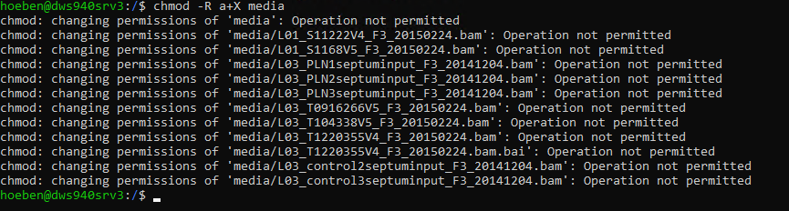

 🡪 no problems

Access to files:

Go to Ubuntu (at the moment it starts as base in conda, but this can be deactivated by conda deactivate)

Then you start in the root (root@dws940srv3:~) this is the root of the ubuntu folder.

Then always make sure the files you need are in the C drive 🡪 ubuntu 🡪 rootfs 🡪 media

Use the command cd ../ to go to root@dws940srv3:/

Here use the command : sudo chmod -R 777 media (media is the directory you are in)

Now you have access to all files in this directory



Using samtools view <filename> | head -10 vs samtools view <filename> | tail – 10 shows that the readdata that is in the end doesn’t contain any information about position/chromosome

Samtools view -c <filename> 🡪 counts number of reads = 20265783 for L01_S11222V4_F3_20150224

Samtools view -c -F 260 <fiilename> 🡪 counts number of mapped reads = 13324391 for same sample

Viewing the top part of the last 6941400 shows ineed that the first are still mapped and the rest is not.